PALM HARBOR MUSEUM
2043 Curlew Rd, Palm Harbor, FL 34683

PRESENTS THE ACOUSTIC SOUNDS OF BLUEGRASS MUSIC

“THIRD SATURDAY BLUEGRASS SERIES”

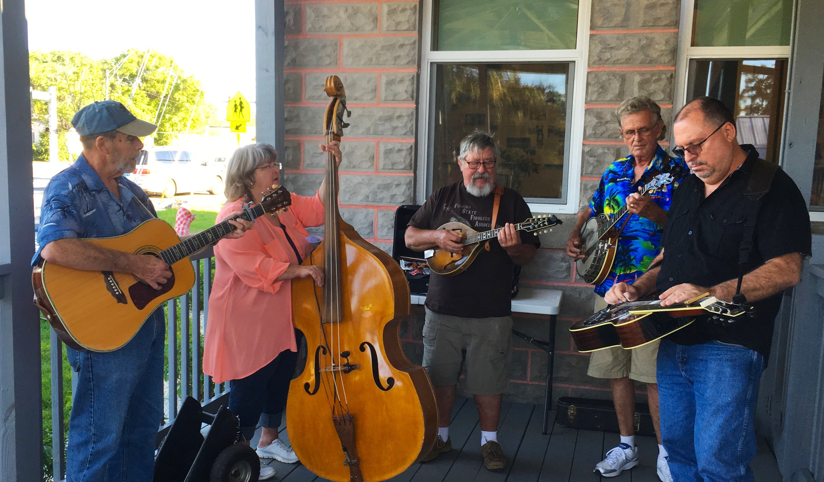

The Bluegrass Band, Stump Hollow, will host a Bluegrass Concert followed by an open jam on the third Saturdays, beginning February 17th through April 21st from 1 - 3 PM, on the back porch of the Palm Harbor Museum, located at 2043 Curlew Road, Palm Harbor, Florida. You are invited to bring lawn chairs and join in the musical fun.

Please join us. There is no charge, but as usual, the Museum welcomes contributions. You are welcome to visit the Museum and discover the History of Palm Harbor and surrounding communities.

Bluegrass music is the acoustic sounds of Bill Monroe and the Kentucky Blue Grass Boys, featuring the Guitar, Mandolin, Banjo, and Bass with High- Lonesome Appalachian Harmony, and family appreciation.

Any questions or details concerning the program, call 315-292-2599. General inquiries for the Museum information, please call 727-724-3054.

